**A Proposal to Investigate Engineering Solutions to Reduce the Urban Area Wild Boar Population Near Hekimköy Complex, Türkbükü, Bodrum**

**1.0 Introduction**

The nature of interactions between humans and wildlife has changed, particularly in urban and suburban environments [1]. An example of this shift is the increase in urban area wild boar population [2]. In Hekimköy Complex (HC), Türkbükü, Bodrum, the rapid spread of wild boars into human-populated areas has created an alarming situation because the simultaneous accommodation of wild boars and humans in the same environment poses severe threats to human safety and property [3], [4]. In recent years, wild boars have created unrest on the site by causing traffic accidents that resulted in the death of the driver or themselves many times at night on dark roads that pass through HC, causing pollution by knocking over garbage bins [5], carrying diseases [6], and attacking and injuring HC residents.

The proposed project aims to reduce the wild boar population within the HC with the three proposed engineering solutions. Its impact is to implement wild boar deterring systems throughout the HC upon detecting wild boar presence, adding an extra layer of security for residents against wild boars. The significance of this project lies in its potential to generate solutions that can be adapted to all regions facing similar disturbances caused by wildlife, regardless of the type of animal species.

**2.0 Problem Definition**

Beyond the potential for traffic accidents in the HC, the pilot study area (PSA), wild boars are responsible for damages to public infrastructure, parks, and private gardens [7] in the PSA. The residents of the PSA are irritated by their raids of trash cans because of the resulting pollution in the PSA. Moreover, wild boars can transmit diseases to the PSA residents and their pets [8] and even pose a physical threat to them [4]. Therefore, wild boars create an unsafe environment for walking and other outdoor activities within the PSA [9].

**2.1 Root Causes**

**2.1.1 Easy Access to Food and Water**

Urban areas' abundant food and water sources strongly attract wild boars [10]. These readily available resources are often found as food waste in the PSA’s trash bins, fruits and vegetables grown in private gardens of the PSA residents, and water bodies.

**2.1.2 Insufficient Hunting Pressure**

Wild boars are attracted to urban areas due to the absence of hunting pressure in their natural habitats [11]. As a result, they overpopulate, leading them to seek food and shelter in urban environments where these resources are more readily available.

**2.1.3 Expanding Urbanization into Forested Areas Occupied by Wild Boars**

Urban expansion into forested areas, previously occupied by wild boars, draws these animals into urban environments as it disrupts their natural habitat [12].

**2.2 Problem Scope**

* Who HC residents
* What: Wild boar intrusion into urban areas through HC
* When: The problem persists year-round but worsens in summer due to the increased PSA population from holiday migrations [13].
* Where: HC, Türkbükü, Bodrum
* Why: Increase in wild boar and human interactions leads to conflicts.
* How: Wild boars cause car accidents and physical harm to people, carry diseases, damage properties, and create pollution [7].

1. **Proposed Solutions**

Three engineering solutions proposed to solve the problem mentioned in the PSA are a Kinect-based deterrent system with an odor repellent, a machine learning-based acoustic deterrent system, and a sensor and artificial intelligence-based visual deterrent system.

**3.1 Kinect-Based Deterrent System with an Odor Repellent**

The introduced system consists of three pieces of hardware internally connected with various signals: a Kinect camera, a control unit [16], and an odor dispenser. The Kinect camera device, known as the "Kinect for Xbox," incorporates several sensors (see Appendix A, Figure 1, and Table 1) to create a 3D depth map of its surroundings [14] to track the movements of objects [15]. The purpose of the system is to send activating signals through the control unit to the odor-repellant dispenser to drive wild boars away after detecting their presence with the help of a Kinect camera. HC electricians will install 30 systems on the lower parts of the 12 street light poles, around the four garbage collection areas, eight empty bushlands, and at the sides of 18 garbage bins within the PSA.

The system will work in three phases. The distance information between the camera and the object will be obtained using Kinect's infrared projection in the image acquisition phase. Then, this information will be used to create a depth image of the object (see Appendix A, Figure 2) [16]. The detection phase will begin with a Binary Large Object (BLOB) analysis, which is helpful for object detection tasks [18], of the shape and size of objects using the depth image (see Appendix A, Figure 3). An extra layer of motion detection by utilizing the optical flow method, which can be mathematically represented (see Appendix A, Figure 4) [16], will be applied to the extracted blobs within the depth image because there can be misidentifications due to the resemblance of animals to rocks or trees. After all, if the captured animal is identified as a wild boar, the odor-repellent secretion phase will begin [19], [20]. A programmable logic controller will receive the incoming signal by a wired communication protocol, utilizing general-purpose input-output pins, and interpret it. Then, it will communicate with the odor-repellent dispenser to trigger the release [21]. The odor-repellent ‘‘Wildschwein-StoppÒ’’ will be filled into the scent dispensers. It claims to mainly deter wild boars by an offensive smell that should reflect a mixture of several predator odors [22].

**3.2. Machine Learning-Based Acoustic Deterrent System**

An acoustic deterrent is being proposed by combining an infrared night vision camera [23] that can detect movements of wild boars in low visibility, along with several machine learning algorithms [24] and an ultrasonic frequency generator (see Appendix B, Figure 1). The Raspberry Pi (Rpi), a microcontroller that will serve as the overall module brain [25], will receive the video straight from the camera that will record surroundings continually. The Rpi will capture frames at a frame rate of one frame per five seconds. Then, the Python OpenCV [26] library, a computer vision library used for image processing tasks, will process the frames [27]. Processed frames will be used to forecast if any wild boars are present in the vicinity. A machine learning (ML) model built on the Convolutional Neural Network (CNN) architecture will be used to make the prediction [28]. As a deep-learning technique for image recognition, CNNs extract simple image patterns, combine them to recognize complex features, and reduce dimensionality for efficient computation [29]. The ML model will be trained using a dataset of wild boar images [28]. According to the prediction about the existence of wild boar, the Rpi will send a signal to the ultrasonic frequency generator, which has an audible range of 10-15 meters with a span of 110 degrees. The ultrasonic repellent will produce frequencies ranging from 15 to 65 kHz, which wild boars can hear and be disturbed by, but humans cannot [30].

Based on the sizes of all hardware components, outer casings will be designed to hold and protect the hardware (see Appendix B, Figure 2). 30 casings will then be placed over streetlights in the PSA, especially near four rubbish collection areas, 18 rubbish bins, and eight vacant bushlands by the electricians of the HC.

**3.3 Sensor and Artificial Intelligence-Based Visual Deterrent System**

Passive Infrared Motion (PIR) Sensors will be configured over the streetlights around the four garbage collection areas, eight vacant bushlands, and 18 trash containers by the electricians of the HC to sense movement of and identify any wild boars. Motion detection will then cause the camera to record live streaming and store it on Rpi [31]. Rpi is a small, single-board computer that can store media files, such as videos or images, on its storage device [25]. After the video is captured, a wild boar detection model will try to detect the presence of wild boars using videos captured by the camera. After the model has finished running, if any wild boars are detected, it will turn on the flashlights to divert them away (see Appendix C, Figures 1 and 2).

PIR sensors use variations in infrared radiation to identify motion [31]. These sensors detect heat from warmer objects than absolute zero [32]. Therefore, they will identify and report motion when a large, warm object like a wild boar enters their field of vision. This report activates a camera connected to the Rpi module to start recording live and storing the video on an Rpi media. After all, the detection phase in the proposed system relies on the YOLO V3 algorithm (see Appendix B, Figure 3), which is renowned for its effectiveness in identifying animal species within video streams [33]. YOLO V3, or "You Only Look Once," operates on the principle of regression, enabling it to predict the classes of detected objects and their corresponding bounding boxes within a single algorithm pass, ensuring identification without extensive comparisons [34], [35]. The Rpi module will be connected to the flashlight. Upon confirmation of a wild boar intrusion, a flashing light will start blinking with irregular repetitions to annoy wild boars and guide them out of the PSA.

1. **Criteria for Assessing Solutions**

Criteria for assessing solutions are feasibility [36], monetary cost [37], and environmental safety impact [38].

**4.1 Feasibility**

The applicability of the three systems in the three proposed solutions will be assessed by verifying the systems’ operational functionality [16], [24], [25], [31], [32]. Practicality assessment of all solutions will involve evaluating each system's construction time and labor requirements [20], [26], [33]. The first and third solutions’ acceptability will be determined based on the suitability of visual and odor-deterrent installation locations to avoid disturbing the PSA residents [39].

**4.2 Monetary Cost**

The cost of purchasing the necessary hardware and software and continuing sustainability will be examined [19], [28], [40]. The monetary cost criterion will also assess the use of available funds at the PSA [41].

**4.3 Environmental Safety Impact**

Whether the three deterrents that will be used in implementing all the proposed systems, odor-repellent [22], [23], ultrasonic frequency [30], [42], and flashing light [43], will harm the ecological balance in the PSA by causing other animals to leave their natural habitats will be evaluated.

1. **Proposed Research Methodology**

The researched methodology to check the solutions against each criteria set consists of literature review [44], [45], market research [46], field observation [47]

**5.1 Literature Review**

The literature review will be used to assess all three of the proposed systems' feasibilities [16], overall monetary costs [48], and environmental safety impacts [23], [30], [43], [49].

**5.2 Market Research**

Market research will be utilized against the monetary cost criterion to reach the monetary values of the devices and products to be used in all proposed solutions [40], [41], [50].

**5.3 Field Observation**

Field observations in the PSA will be used across all proposed solutions to assess the acceptability of the proposed deployment sites, specify material choices based on weather conditions, and evaluate the environmental impacts of the systems’ deterrents on PSA species.

**6.0 Appendices**

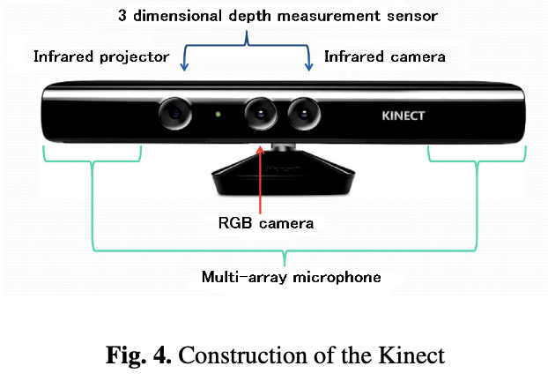**Appendix A – Kinect-Based Deterrent System with an Odor Repellent**

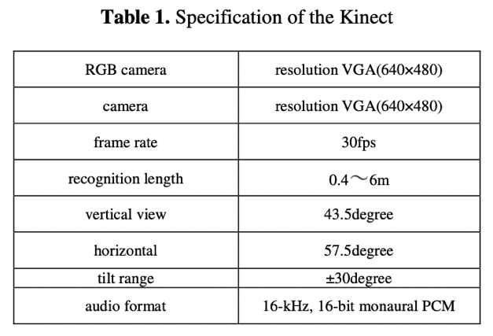

Fig. 1: Kinect Construction [16]

Table 1: Kinect Specification [16]

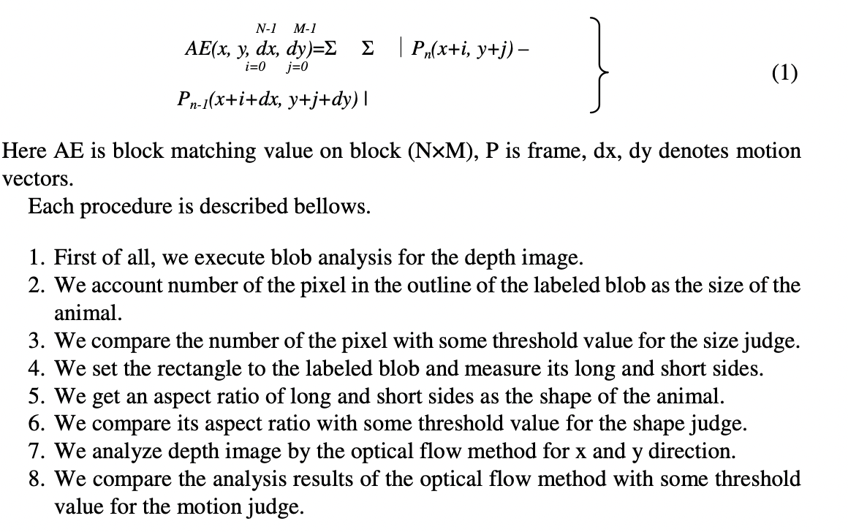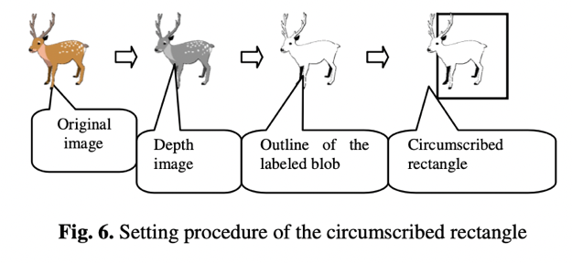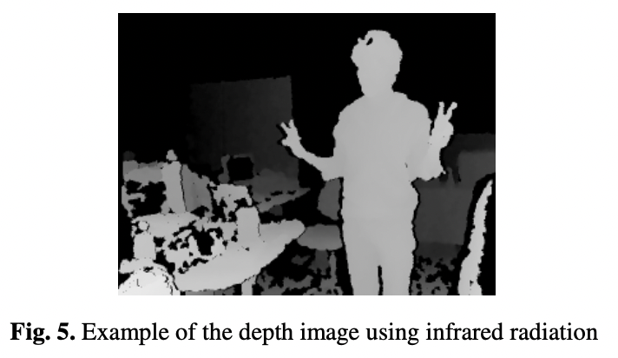

Fig. 3: Circumscribed Rectangle Adjustment Procedure [16]

Fig. 2: Infrared Radiation Depth Image [16]

Fig. 4: Optical Flow Method Mathematical Description(Here, AE is the block matching value on the block (N×M), P is the frame, and dx and dy denote motion vectors.) [16]

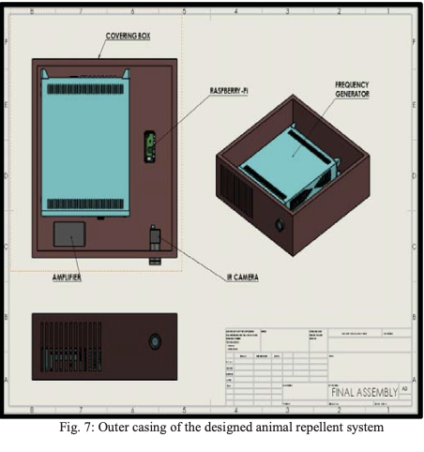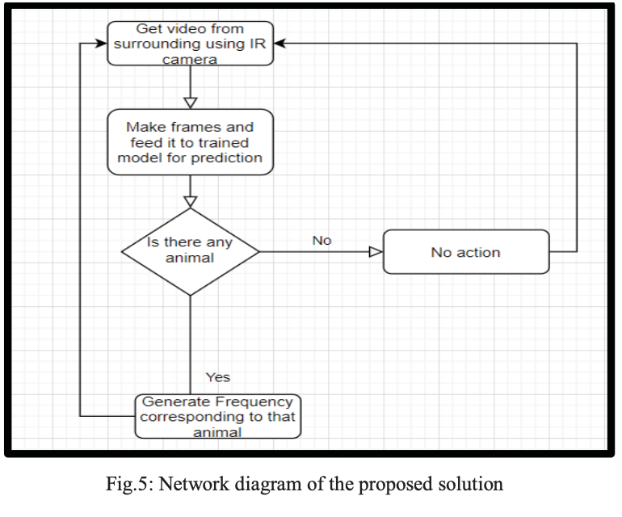**Appendix B – Machine Learning-Based Acoustic Deterrent System**

Fig. 1: Solution Network Diagram [24]

Fig. 2: Designed Animal Repellent System Outer Casing [24]

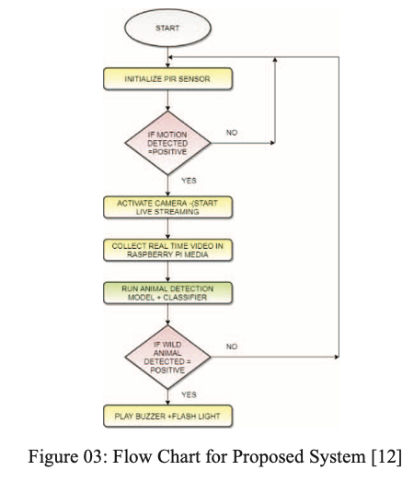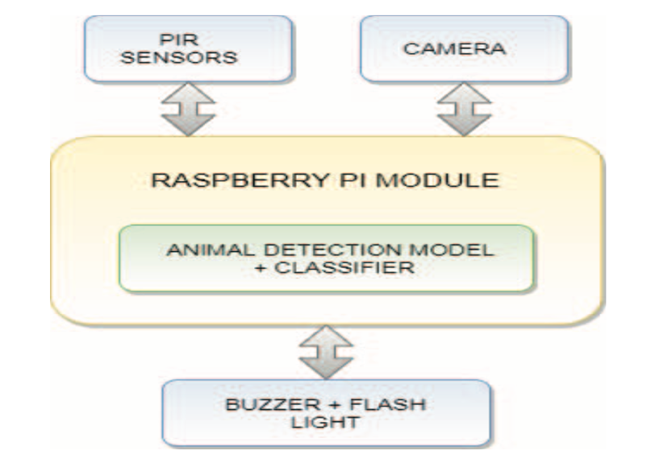**Appendix C – Sensor and Artificial Intelligence-Based Visual Deterrent System**

Fig. 3: YOLO V3 Network Architecture [31]

FLASHLIGHT

Fig. 2: System Flow Chart [31]

Fig. 1: System Architecture Block Diagram [31]

FLASHLIGHT

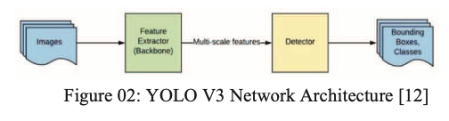

**7.0 References**

[1] C. Conejero, R. Castillo-Contreras, C. González-Crespo, E. Serrano, G. Mentaberre, S. Lavín, and J. R. López-Olvera, "Past experiences drive citizen perception of wild boar in urban areas," *Mammalian Biology: Zeitschrift für Säugetierkunde*, vol. 96, pp. 68-72, May 2019. [Online]. Available: Springer Nature Journals, https://www.springernature.com/gp/products/journals. [Accessed Oct. 28, 2023].

[2] C. Hunold and M. Mazuchowski, "Human-wildlife coexistence in urban wildlife management: Insights from nonlethal predator management and rodenticide bans," *Animals*, vol. 10, no. 11, pp. 1-15, November 2020. [Online]. Available: Scopus, https://www.scopus.com/search/form.uri?display=basic#basic. [Accessed Oct. 28, 2023].

[3] S. Tampakis, V. Andrea, T. Panagopoulos, P. Karanikola, R. Gkarmiri, and T. Georgoula, "Managing the Conflict of Human-Wildlife Coexistence: A Community-Based Approach," *Land*, vol. 12, no. 832, p. 832+, April 2023. [Online]. Available: Scopus, https://www.scopus.com/search/form.uri?display=basic#basic. [Accessed Oct. 28, 2023].

[4] S. Cahill, F. Llimona, L. Cabañeros, and F. Calomardo, "Characteristics of wild boar (Sus scrofa) habituation to urban areas in the Collserola Natural Park (Barcelona) and comparison with other locations," *Animal Biodiversity and Conservation*, vol. 35, no. 2, pp. 221-233, 2012. [Online]. Available: Directory of Open Access Journals, https://doaj.org. [Accessed Oct. 28, 2023].

[5] Anadolu Agency, “Bodrum locals feeding wild boars to keep them in the forest,” *Hürriyet Daily News: Arts & Life*, p. 3, Jun. 15, 2018. [Online]. Available: Hürriyet Daily News, https://www.hurriyetdailynews.com. [Accessed Oct. 28, 2023].

[6] H. Albayrak, E. Ozan, and A. Cavunt, "A serological survey of selected pathogens in wild boar (Sus scrofa) in northern Turkey," *European Journal of Wildlife Research*, vol. 59, no. 6, pp. 893-897, June 2013. [Online]. Available: Springer Nature Journals, https://www.springernature.com/gp/products/journals. [Accessed Oct. 28, 2023].

[7] R. Castillo-Contreras, J. Carvalho, E. Serrano, G. Mentaberre, X. Fernández-Aguilar, A. Colom, C. González-Crespo, S. Lavín, and J. R. López-Olvera, "Urban wild boars prefer fragmented areas with food resources near natural corridors," *Science of the Total Environment*, vol. 615, pp. 282-288, January 2018. [Online]. Available: ScienceDirect, https://www.sciencedirect.com. [Accessed Oct. 28, 2023].

[8] X. J. Meng, D. S. Lindsay, and N. Sriranganathan, "Wild boars as sources for infectious diseases in livestock and humans," *Philosophical Transactions: Biological Sciences*, vol. 364, no. 1530, pp. 2697-2707, September 2009. [Online]. Available: JSTOR Journals, https://www.jstor.org. [Accessed Oct. 29, 2023].

[9] T. Ikeda, N. Kuninaga, T. Suzuki, S. Ikushima, and M. Suzuki, "Tourist-wild boar (Sus scrofa) interactions in urban wildlife management," *Global Ecology and Conservation*, vol. 18, May 2019. [Online]. Available: ScienceDirect, https://www.sciencedirect.com. [Accessed Oct. 28, 2023].

[10] J. Carpio, M. Apollonio, and P. Acevedo, "Wild ungulate overabundance in Europe: contexts, causes, monitoring and management recommendations," *Mammal Review*, vol. 51, no. 1, pp. 95-108, January 2021. [Online]. Available: OAIster, https://www.oclc.org/en/oaister.html. [Accessed Oct. 28, 2023].

[11] L. Nelli, B. Schehl, R. A. Stewart, D. J. McCafferty, C. Scott, S. Ferguson, and S. MacMillan, "Predicting habitat suitability and connectivity for management and conservation of urban wildlife: A real-time web application for grassland water voles," *Journal of Applied Ecology*, vol. 59, no. 4, pp. 1072-1085, April 2022. [Online]. Available: Scopus, https://www.scopus.com/search/form.uri?display=basic#basic. [Accessed Oct. 28, 2023].

[12] L. L. Griffin, A. Haigh, K. Conteddu, M. Andaloc, S. Ciuti, and P. McDonnell, "Reducing risky interactions: Identifying barriers to the successful management of human-wildlife conflict in an urban parkland," *People and Nature*, vol. 4, no. 4, pp. 918-930, August 2022. [Online]. Available: Scopus, https://www.scopus.com/search/form.uri?display=basic#basic. [Accessed Oct. 28, 2023].

[13] C. González-Crespo, B. Martínez-López, C. Conejero, R. Castillo-Contreras, E. Serrano, J. M. López-Martín, S. Lavín, and J. R. López-Olvera, "Predicting human-wildlife interaction in urban environments through agent-based models," *Landscape and Urban Planning*, vol. 240, no. 104878, December 2023. [Online]. Available: ScienceDirect, https://www.sciencedirect.com. [Accessed Oct. 28, 2023].

[14] International Business Times, “A look at the Xbox One Kinect: what it does and what the Xbox One can do without it,” *International Business Times*, Nov. 25, 2013. [Online]. Available: Scopus, https://www.scopus.com/search/form.uri?display=basic#basic. [Accessed Oct. 28, 2023].

[15] International Business Times, “Xbox One: what’s up for developers, gamers and the Kinect,” *International Business Times*, Jun. 19, 2014. [Online]. Available: Scopus, https://www.scopus.com/search/form.uri?display=basic#basic. [Accessed Oct. 28, 2023].

[16] F. Takeda, "Generation method of the trigger signal for the automatic capture system to the harmful animals with intelligent image processing," in *Distributed Computing and Artificial Intelligence: Proc. of the 11th Int. Conf. on Advances in Intelligent Systems and Computing, DCAI 2014, 4-6 June 2014, Salamanca, Spain* [Online]. Available: Scopus, https://www.scopus.com/search/form.uri?display=basic#basic. [Accessed: Oct. 28, 2023].

[17] J. Wevers, J. Fattebert, J. Casaer, T. Artois, and N. Beenaerts, "Trading fear for food in the Anthropocene: How ungulates cope with human disturbance in a multi-use, suburban ecosystem," *Science of the Total Environment*, vol. 741, no. 140369, November 2020. [Online]. Available: Scopus, https://www.scopus.com/search/form.uri?display=basic#basic. [Accessed Oct. 28, 2023].

[18] S. Rajkumar, A. Hariharan, S. Girish, and M. Arulmurugan, “An efficient vehicle detection and shadow removal using Gaussian mixture models with blob analysis for machine vision application,” *SN Computer Science*, vol. 4, no. 5, pp. 450-460, September 2023. [Online]. Available: Scopus, https://www.scopus.com/search/form.uri?display=basic#basic. [Accessed Oct. 28, 2023].

[19] T. Kušta, Z. Keken, M. Ježek, and Z. Kůta, "Effectiveness and costs of odor repellents in wildlife-vehicle collisions: A case study in Central Bohemia, Czech Republic," *Transportation Research Part D: Transport and Environment*, vol. 38, pp. 1-5, July 2015. [Online]. Available: ScienceDirect, https://www.sciencedirect.com. [Accessed Oct. 28, 2023].

[20] M. Bíl, R. Andrášik, T. Bartonička, Z. Křivánková, and J. Sedoník, "An evaluation of odor repellent effectiveness in the prevention of wildlife-vehicle collisions," *Journal of Environmental Management*, vol. 205, pp. 209-214, January 2018. [Online]. Available: ScienceDirect, https://www.sciencedirect.com. [Accessed Oct. 28, 2023].

[21] S. M. Enosh and N. S. George, "An efficient implementation of protocol operation control unit of FlexRay communication controller," in *Proc. of the 2014 1st Int. Conf. on Computational Systems and Communications (ICCSC), 17-18 December 2014, Trivandrum, India* [Online]. Available: IEEE Xplore, http://www.ieee.org. [Accessed: 28 Oct. 2023].

[22] Schlageter and D. Haag-Wackernagel, "Evaluation of an odor repellent for protecting crops from wild boar damage," *Journal of Pest Science*, vol. 85, no. 2, pp. 209-215, June 2012. [Online]. Available: Springer Nature Journals, https://www.springernature.com/gp/products/journals. [Accessed Oct. 28, 2023].

[23] S. Giordano, I. Seitanidis, M. Ojo, D. Adami, and F. Vignoli, "IoT solutions for crop protection against wild animal attacks," in *Proc. of the 2018 IEEE Int. Conf. on Environmental Engineering (EE), 12-14 March 2018, Milan, Italy* [Online]. Available: IEEE Xplore, http://www.ieee.org. [Accessed: 28 Oct. 2023].

[24] D. Ranparia, G. Singh, A. Rattan, H. Singh, and N. Auluck, "Machine learning-based Acoustic Repellent System for Protecting Crops against Wild Animal Attacks," in *Proc. of the 2020 IEEE 15th Int. Conf. on Industrial and Information Systems (ICIIS), 26-28 November 2020, Rupnagar, India* [Online]. Available: IEEE Xplore, http://www.ieee.org. [Accessed: 28 Oct. 2023].

[25] M. Dubovečak, E. Dumić, and A. Bernik, “Face detection and recognition using Raspberry PI Computer,” *Technical Journal / Tehnicki Glasnik*, vol. 17, no. 3, pp. 346-352, September 2023. [Online]. Available: The Belt and Road Initiative Reference Source, https://www.ebsco.com/products/research-databases/belt-and-road-initiative-reference-source [Accessed Oct. 28, 2023].

[26] G. Singh, I. Gupta, J. Singh, and N. Kaur, “Face recognition using open-source computer vision library (OpenCV) with Python,” in *Proc. of the 2022 10th Int. Conf. on Reliability, Infocom Technologies and Optimization (Trends and Future Directions) (ICRITO), 13-14 October 2022, Noida, India* [Online]. Available: IEEE Xplore, http://www.ieee.org. [Accessed: 28 Oct. 2023].

[27] A. Pradeep, M. Asrorov, and M. Quronboyeva, “Advancement of sign language recognition through technology using Python and OpenCV,” in *Proc. of the 2023 7th Int. Multi-Topic ICT Conf. (IMTIC), 10-12 May 2023, Jamshoro, Pakistan* [Online]. Available: IEEE Xplore, http://www.ieee.org. [Accessed: 28 Oct. 2023].

[28] A. Shrivastava, M. Chakkaravathy, and M. A. Shah, “A comprehensive analysis of machine learning techniques in biomedical image processing using Convolutional Neural Network,” in *Proc of the 2022 5th Int. Conf. on Contemporary Computing and Informatics (IC3I), 14-16 December 2022, Uttar Pradesh, India* [Online]. Available: IEEE Xplore, http://www.ieee.org. [Accessed: 28 Oct. 2023].

[29] P. Simard, D. Steinkraus, and J. Platt, "Best practices for convolutional neural networks applied to visual document analysis," in *Proc. of the 7th Int. Conf. on Document Analysis and Recognition, 6 August 2003, Edinburgh, UK* [Online]. Available: IEEE Xplore, http://www.ieee.org. [Accessed: 28 Oct. 2023].

[30] R. S. Heffner and H. E. Heffner, "Hearing in domestic pigs (Sus scrofa) and goats (Capra hircus)," *Hearing Research*, vol. 48, no. 3, pp. 231-240, October 1990. [Online]. Available: Scopus, https://www.scopus.com/search/form.uri?display=basic#basic. [Accessed Oct. 28, 2023].

[31] H. D. Patil and N. F. Ansari, "Intrusion detection and repellent system for wild animals using artificial intelligence of things," in *Proc. of the 2022 Int. Conf. on Computing, Communication and Power Technology (IC3P), 7-8 January 2022, Visakhapatnam, India* [Online]. Available: IEEE Xplore, http://www.ieee.org. [Accessed: 28 Oct. 2023].

[32] J. Andrews, M. Kowsika, A. Vakil, and J. Li, “A motion-induced passive infrared (PIR) sensor for stationary human occupancy detection,” in *Proc. of the 2020 IEEE/ION Position, Location and Navigation Symposium (PLANS), 20-23 April 2020, Portland, USA* [Online]. Available: IEEE Xplore, http://www.ieee.org. [Accessed: 28 Oct. 2023].

[33] S. Yang, H. Ge, and Q. Li, “Infrared night camouflage target detection algorithm based on improved YOLO v3,” in *Proc of the 2022 IEEE 8th Int. Conf. on Computer and Communications (ICCC), 9-12 December 2022, Chengdu, China* [Online]. Available: IEEE Xplore, http://www.ieee.org. [Accessed: 28 Oct. 2023].

[34] M. Sharmila F, C. K. Amal Kumar, A. Varsha D, and E. Sarayu, "Animal repellent system for smart farming using AI and Edge Computing," in *Proc. of the 2022 8th Int. Conf. on Advanced Computing and Communication Systems (ICACCS), 25-26 March 2022, Coimbatore, India* [Online]. Available: IEEE Xplore, http://www.ieee.org. [Accessed: 28 Oct. 2023].

[35] D. Carniato, J. Sereno, J. Vicente, J. A. Blanco, M. Scandura, M. Apollonio, P. Palencia, and P. Acevedo, "Implementing practical methods to estimate the population density of wild boar and other wild mammals: field trials and development of automatic identification," *EFSA Supporting Publications*, vol. 19, no. 9, pp. 1-48, August 2022. [Online]. Available: Academic Search Ultimate, https://www.ebsco.com/products/research-databases/academic-search-ultimate. [Accessed Oct. 28, 2023].

[36] S. McLeod, “Feasibility studies for novel and complex projects: Principles synthesized through an integrative review,” *Project Leadership and Society*, vol. 2, December 2022. [Online]. Available: ScienceDirect, https://www.sciencedirect.com. [Accessed Oct. 28, 2023].

[37] X. Wang, Z. Du, Y. Wang, J. Wang, S. Huang, Y. Wang, J. Gu, W. Deng, S. Gilmour, J. Li, and Y. Hao, "Impact and cost-effectiveness of biomedical interventions on adult Hepatitis B elimination in China: A mathematical modeling study," *Journal of Epidemiology and Global Health*, vol. 13, no. 3, pp. 517-527, June 2023. [Online]. Available: Springer Nature Journals, https://www.springernature.com/gp/products/journals. [Accessed Oct. 28, 2023].

[38] D. W. North, "Engineering a safer world: systems thinking applied to safety," *Risk Analysis*, vol. 34, no. 2, pp. 391-396, February 2014. [Online]. Available: Science Citation Index Expanded, https://clarivate.com/products/scientific-and-academic-research/research-discovery-and-workflow-solutions/webofscience-platform/web-of-science-core-collection/science-citation-index-expanded/. [Accessed Oct. 28, 2023].

[39] J. Rovira, M. Nadal, M. Schuhmacher, and J. L. Domingo, "Human exposure to trace elements through the skin by direct contact with clothing: Risk assessment," *Environmental Research*, vol. 140, pp. 308-316, July 2015. [Online]. Available: ScienceDirect, https://www.sciencedirect.com. [Accessed Oct. 28, 2023].

[40] P. C. Lyon, C. Mannaris, M. Gray, R. Carlisle, F. V. Gleeson, D. Cranston, F. Wu, and C. C. Coussios, "Large-volume hyperthermia for safe and cost-effective targeted drug delivery using a clinical ultrasound-guided focused ultrasound device," *Ultrasound in Medicine & Biology*, vol. 47, no. 4, pp. 982-997, April 2021. [Online]. Available: Scopus, https://www.scopus.com/search/form.uri?display=basic#basic. [Accessed Oct. 28, 2023].

[41] G. M. M. Zarco and V. O. Monroy, "Effectiveness of low-cost deterrents in decreasing livestock predation by felids: a case in Central Mexico," *Animal Conservation*, vol. 17, no. 4, pp. 371-378, August 2014. [Online]. Available: Academic Search Ultimate, https://www.ebsco.com/products/research-databases/academic-search-ultimate. [Accessed Oct. 28, 2023].

[42] W. L. Nyborg, "Determining risk to subjects: exposure to ultrasound," *IRB*, vol. 9, no. 3, pp. 1-5, May 1987. [Online]. Available: Scopus, https://www.scopus.com/search/form.uri?display=basic#basic. [Accessed Oct. 28, 2023].

[43] Y. Wang, J. Jian, B. Sun, Y. Wei, D. Pan, J. Cao, and Y. Shen, "Engineering of onsite point-of-care testing of Fe3+ with visual ratiometric fluorescent signals of copper nanoclusters-driven portable smartphone," *Sensors and Actuators: B. Chemical*, vol. 370, November 2022. [Online]. Available: ScienceDirect, https://www.sciencedirect.com. [Accessed Oct. 28, 2023].

[44] G. Wagner, R. Lukyanenko, and G. Paré, "Artificial intelligence and the conduct of literature reviews," *Journal of Information Technology*, vol. 37, no. 2, pp. 209-226, June 2022. [Online]. Available: Scopus, https://www.scopus.com/search/form.uri?display=basic#basic. [Accessed Oct. 28, 2023].

[45] K. D. Ward, D. P. Mason, G. Park, and R. Fyall, "Exploring nonprofit advocacy research methods and design: a systematic review of the literature," *Nonprofit and Voluntary Sector Quarterly*, vol. 52, no. 5, pp. 1210-1231, October 2023. [Online]. Available: Scopus, https://www.scopus.com/search/form.uri?display=basic#basic. [Accessed Oct. 28, 2023].

[46] Wm. J. Gonzenbach and Michael Mitrook, "The market research toolbox: a concise guide for beginners," *International Journal of Public Opinion Research*, vol. 8, no. 4, pp. 411-412, December 1996. [Online]. Available: Business Source Ultimate, https://www.ebsco.com/products/research-databases/business-source-ultimate. [Accessed Oct. 28, 2023].

[47] C. T. Husbands, "Field research: a sourcebook and field manual R. G. Burgess," *The British Journal of Criminology*, vol. 23, no. 2, pp. 198–199, April 1983. [Online]. Available: Academic Search Ultimate, https://www.ebsco.com/products/research-databases/academic-search-ultimate. [Accessed Oct. 28, 2023].

[48] A. I. Khalyasmaa, E. L. Zinovieva, and S. A. Eroshenko, "Formation features of criteria for assessing the feasibility of innovative technical solutions," in *Proc. of the* *2018 3rd Int. Conf. on Human Factors in Complex Technical Systems and Environments (ERGO), 2018,* *St. Petersburg, Russia* [Online]. Available: https://ieeexplore.ieee.org/document/8443920?arnumber=8443920. [Accessed: Mar. 20, 2023].

[49] T. Wu, J. Ruan, C. Chen, and D. Huang, "Field observation and experimental investigation on the breakdown of the air gap of AC transmission line under forest fires," in *Proc. of the 2011 IEEE Power Engineering and Automation Conf., 2011, Wuhan, China* [Online]. Available: IEEE Xplore, http://www.ieee.org. [Accessed: 28 Oct. 2023].

[50] J. Casaer, P. Jansen, D. Roy, P. Stephens, A. J. Blanco, Y. Liefting, J. Vicente, and G. Smith, "Improvement of information technology tools to collect, process and analyze data on wildlife population," EFSA Supporting Publications, vol. 20, no. 8, pp. 1-22, August 2023. [Online]. Available: Academic Search Ultimate, https://www.ebsco.com/products/research-databases/academic-search-ultimate. [Accessed Oct. 28, 2023].